Order Of Lenten Service

Opening Hymn: TLH 140

Reading: Lent I

The History of the Passion of our Lord

Sermon Hymn: TLH 142

Sermon Text: Mark 4:26-29

Mysterious Growth

Prayer

Holy Communion

The Lord's Prayer

The Blessing

Closing Hymn: TLH 147

* * * * * * * * * * * * *

Koinonia Hour

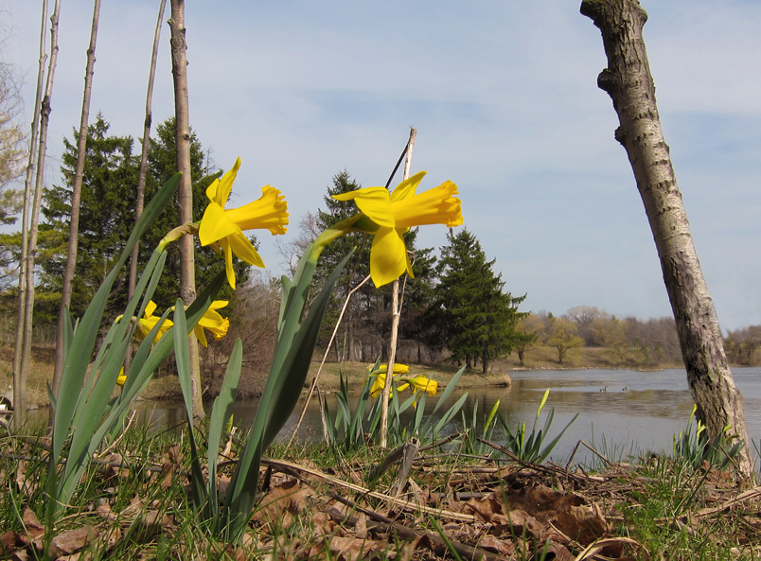

Sign Of Spring

Water
Of
Life

3 March 2019

W A T E R O F L I F E

Independent Christian Church—Conservative Lutheran Doctrine

Worship Service: 9:30 a.m. Bible Study: 10:45 a.m.

Larry Cooper, Pastor E-Mail address:
111 N. Ridge Road lcooper@wateroflife.cc
Coon Valley, WI 54623 Web Site:
www.wateroflife.cc

* * * * * * * * * * * * * * * * * * * * * * * * * * *

Sermon Text: Mark 4:26-29

Mysterious Growth

* * * * * * * * * * * * * * * * * * * * * * * * * * *

Mark 4:26 And he said, So is the kingdom of God, as if a man should cast seed into the ground;
:27 And should sleep, and rise night and day, and the seed should spring and grow up, he knoweth not how.
:28 For the earth bringeth forth fruit of herself; first the blade, then the ear, after that the full corn in the ear.
:29 But when the fruit is brought forth, immediately he putteth in the sickle, because the harvest is come.
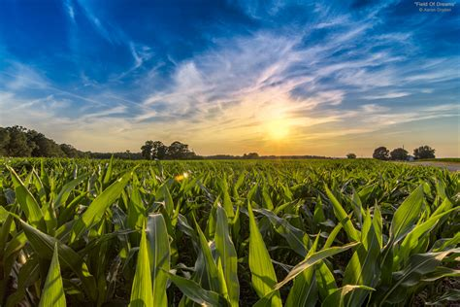

All the world is God’s own field,
Fruit unto His praise to yield;
Wheat and tares together sown,
Unto joy or sorrow grown;
First the blade and then the ear,
Then the full corn shall appear.
Lord of harvest, grant that we
Wholesome grain and pure may be.
TLH 574 v. 2

